JavaScript Cheat Sheet

**Javascript built into HTML**

[onmouseover/onmouseout - When the mouse passes over an element, something will happen](http://www.w3schools.com/js/tryit.asp?filename=tryjs_events_onmouse)

[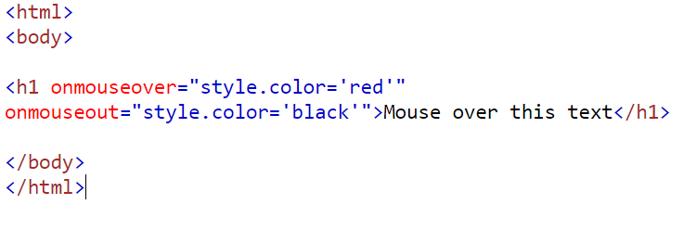](http://www.w3schools.com/js/tryit.asp?filename=tryjs_events_onmouse)

* This text becomes red in the program when you mouse over “Mouse over this text” and becomes black when otherwise.

Adding a button -Click a button which can display something

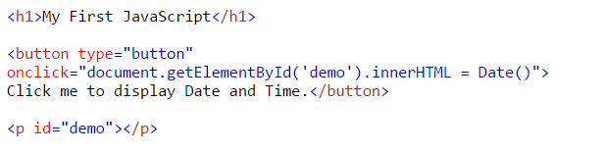

-This is what the code will display. The button displays date and time.

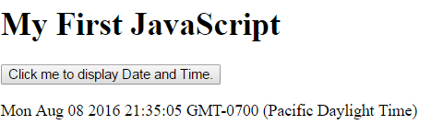

-If you want an alert box, which is like a pop-up box, to appear when you click the button, write it like this.

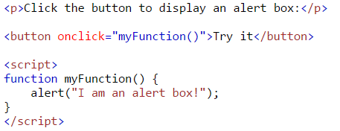

Confirming pop-up- If you want a confirmation from the user, a pop-up box will appear.

https://lh6.googleusercontent.com/c3-wsIG9YmK5fX4jczbNCIdi5NnkitPrvqX15szgA1nvERahfPJaBJOchf-QIXgzv-ogmM27fTfGruszfXA4epzqlx9ZdyaN1FZEs8EWX0dKJ3LecZE3JgJqXwAN7FBAKdN4pevV

-And a pop-up box will appear where you will have to click ok or cancel

**Javascript Functions**

For Loop

for (*statement 1*; *statement 2*; *statement 3*) {

*code block to be executed*

}

If….else

if (hour < 18) {  
   console.log("Good day");  
} else {  
    console.log("Good evening");  
}

**More complicated JavaScript with associated HTML**

Display after a set amount of time

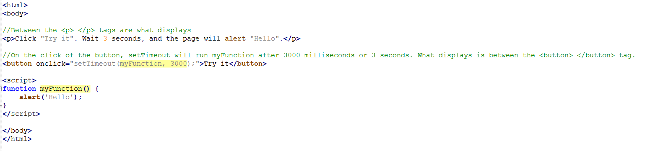

Before the Click After the click and 3 seconds, the alert pops up

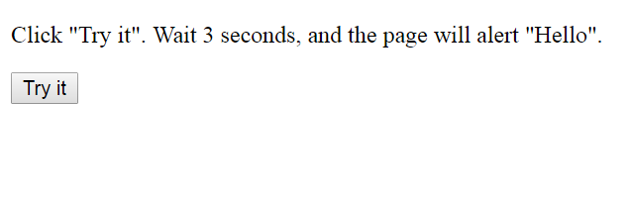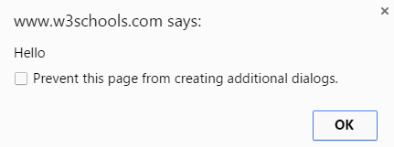

If you want a button to continuously move an object over a timeframe, visit this url link to see it for yourself!

<http://www.w3schools.com/howto/tryit.asp?filename=tryhow_js_animate_3>

Also, here are some ideas for ways to incorporate javascript into your code.

<http://www.d.umn.edu/itss/support/Training/Online/DreamweaverIntro4/fun_with_javascript.htm#Example4>

To look at how they do it in code, click Example#Alternate (right of the screen)  and then View Source (located at the top of the screen).